绝密★启用前
2017年普通高等学校招生全国统一考试
英 语
本试卷共150分，共14页。考试结束后，将本试卷和答题卡一并交回。
注意事项：
1.答题前，考生先将自己的姓名、准考证号码填写清楚，将条形码准确粘贴在条形码区域内。
2.选择题必须使用2B铅笔填涂；非选择题必须使用0.5毫米黑字迹的签字笔书写，字体工整，笔迹清楚。
3.请按照题号顺序在各题目的答题区域内作答，超出答题区域书写的答案无效；在草稿纸、试题卷上答题无效。
4.作图可先用铅笔画出，确定后必须用黑色字迹的签字笔描黑。
5.保持卡面清洁，不要折叠、不要弄破、弄皱，不准使用涂改液、修正带、刮纸刀。

第一部分 听力（共两节，满分30分）
做题时，先将答案标在试卷上，录音结束后，你将有两分钟的时间将试卷上的答案转涂到答题卡上。
第一节 （共5小题，每小题1.5分，满分7.5分）
听下面5段对话，每段对话后有一个小题，从题中所给的A、B、C三个选项中选出最佳答案。听完每段对话后，你都有10秒钟的时间来回答有关小题和阅读下一小题。每段对话仅读一遍。
例：How much is the shirt?
A．£ 19.15 B．£9.18 C．£9.15
答案是C。
1．What will the woman do this afternoon?
A．Do some exercise. B．Go shopping. C． Wash her clothes.
2．Why does the woman call the man?
A ．To cancel a flight. B． To make an apology. C． To put off a meeting.
3．How much more does David need for the car?
A．$ 5,000. B．$20,000. C．$25,000.
4．What is Jane doing?
A．Planning a tour. B．Calling her father. C．Asking for leave.
5 ．How does the man feel?
A．Tied. B．Dizzy. C．Thirsty.
第二节（共15小题；每小题1.5分，满分22.5分）
听下面5段对话或独白。每段对话或独白后有几个小题，从题中所给的A、B、C三个选项中选出最佳选项。听每段对话或独白前，你将有时间阅读各个小题，每小题5秒钟；听完后，各小题将给出5秒钟的作答时间。每段对话或独白读两遍。

听第6段材料，回答第6、7题。
6. What does Jack want to do?
A. Watch TV. B. Play outside. C. Go to the zoo.
7. Where does the conversation probably take place?
A. At home. B. In a cinema. C. In a supermarket.

听第7段材料，回答第8至10题。
8. What does Richard do?
A. He’s a newsman. B. He’s a manager. C. He’s a researcher.
9. Where is Richard going next week?
A. Birmingham. B. Mexico City. C. Shanghai.
10. What will the speakers do tomorrow?
A. Eat out together. B. Visit a university. C. See Professor Hayes.

听第8段材料，回答第11至13题。
11. What is the probable relationship between the speakers?
A. School friends.
B. Teacher and student.
C. Librarian and library user.
12. Why does Jim suggest Mary buy the book?
A. It’s sold at a discount price.
B. It’s important for her study.
C. It’s written by Professor Lee.
13. What will Jim do for Mary?
A. Share his book with her.
B. Lend her some money.
C. Ask Henry for help.
听第9段材料，回答第14至16题。
14.Where does Stella live?
A. In Memphis B. In Boston C. In St Louis
15.What would Peter and his family like to do on Beale Street?
A.Visit a museum B. Listen to music C. Have dinner
16.What kind of hotel does Peter prefer?
A. A big one B. A quite one C.A modern one
听第10段材料，回答第17至20题。
17.How many lab sessions will the students have every week?
A. One B. Two C. Three
18.What are the students allowed to wear in the lab ?
A.Long scarves B.Loose clothes C.Tennis shoes
19.Why should the students avoid mixing liquid with paper?
A. It may cause a fire B.It may create waste C. It may produce pollution
20.What does the speaker mainly talk about?
A.Grades the student will receive
B.Rules the students should follow
C. Experiments the students will do.
第二部分 阅读理解（共两节，满分40分）
- （共15小题；每小题2分，满分30分）
阅读下列短文，从每题所给的A、B、C和D四个选项中，选出最佳答案。
A
In the coming months, we are bringing together artists form all over the globe, to enjoy speaking Shakespeare’s plays in their own language, in our Globe, within the architecture Shakespeare wrote for. Please come and join us.
National Theatre of China Beijing|Chinese
This great occasion(盛会) will be the National Theatre of China’s first visit to the UK. The company’s productions show the new face of 21st century Chinese theatre. This production of
4页
Shakespeare’s Richard III will be directed by the National’s Associate Director，Wang Xiaoying.
Date & Time : Saturday 28 April,2.30pm & Sunday 29 April,1.30pm & 6.30pm

Marjanishvili Theatre Tbilisi | Georgian
One of the most famous theatres in Georgia,the Marjanishvili,founded in 1928,appears regularly at theatre festivals all over the world. This new production of It is helmed（指导）by the company’s Artistic Director Levan Tsuladze.
Date & Time :Friday 18May,2.30pm & Saturday 19May,7.30pm

Deafinitely Theatre London | British Sign Language （BSL）
By translating the rich and humourous text of Love’s Labour’s Lost into the physical language of BSL,Deafinitely Theatre creates a new interpretation of Shakespeare’s comedy and aims to build a bridge between deaf and hearing worlds by performing to both groups as one audience.
Date & Time : Tuesday 22 May,2.30pm & Wednesday 23 May,7.30pm

Habima National Theatre Tel Aviv | Hebrew
The Habima is the centre of Hebrew-language theatre worldwide ,Founded in Moscow after the 1905 revolution, the company eventually settled in Tel Aviv in the late 1920s,Since 1958, z&xxk they have been recognised as the national theatre of Israel .This production of Shakespeare’s The Merchant of Venice marks their first visit to the UK.
Date & Time :Monday 28May,7.30 & Tuesday 29 May,7.30pm

21.which play will be performed by the National Theatre of China?
A.Richard Ⅲ. B.Lover’s Labour’s Lost
C.As You Like It D.The Merchant of Venice
22.What is special about Deafinitely Theatre?
A.It has two groups of actors B.It is the leading theatre in London
C.It performs plays in BSL D.It is good at producing comedies
23.When can you see a play in Hebrew?
A.On Saturday 28 April. B.On Sunday 29 April
C.On Tuesday 22 May. D. On Tuesday 29 May
5页
B
I first met Paul Newman in 1968, when George Roy Hill, the director of Butch Cassidy and the Sundance Kid, introduced us in New York City. When the studio didn’t want me for the film - it wanted somebody as well known as Paul - he stood up for me. I don’t know how many people would have done that; they would have listened to their agents or the studio powers.
The friendship that grew out of the experience of making that film and The Sting four years later had its root in the fact that although there was an age difference, we both came from a tradition of theater and live TV. We were respectful of craft（技艺）and focused on digging into the characters we were going to play. Both of us had the qualities and virtues that are typical of American actors: humorous, aggressive, and making fun of each other - but always with an underlying affection. Those were also at the core（核心）of our relationship off the screen.
We shared the brief that if you’re fortunate enough to have success, you should put something back - he with his Newman’s Own food and his Hole in the Wall camps for kids who are seriously ill, and me with Sundance and the institute and the festival. Paul and I didn’t see each other all that regularly, but sharing that brought us together. We supported each other financially and by showing up at events.
I last saw him a few months ago. He’d been in zxx.k and out of the hospital.He and I both knew what the deal was,and we didn’t talk about it.Ours was a relationship that didn’t need a lot of words.
24.Why was the studio unwilling to give the role to author at first?
A.Paul Newman wanted it. B.The studio powers didn’t like his agent.
C.He wasn’t famous enough. D.The director recommended someone else.
25.Why did Paul and the author have a lasting friendship?
A.They were of the same dge. B.They worked in the same theater.
C.They were both good actors. D.They han similar charactertics.
26.What does the underlined word “that” in paragraph 3 refer to?
A.Their belief. B.Their care for chileden.
C.Their success. D.Their support for each other.
27.What is the author’s purpose in writing the test?
A.To show his love of films. B.To remember a friend.
C.To introduce a new movie. D.To share his acting experience.

C
Terrafugia Inc. said Monday that its new flying car has completed its first flight, bringing the company closer to its goal of selling the flying car within the next year. The vehicle-named the Transition – has two seats， four wheels and wings that fold up so it can be driven like a car. The Transition, which flew at 1,400 feet for eight minutes last month, can reach around 70 miles per hour on the road and 115 in the air. It flies using a 23-gallon tank of gas and bums 5 gallons per hour in the air. On the ground, it gets 35 miles per gallon.
Around 100 people have already put down a $10,000 deposit to get a Transition when they go on sale, and those numbers will likely rise after Terrafugia introduces the Transition to the public later this week at the New York Auto Show. But don’t expect it to show up in too many driveways. It’s expected to cost $279,000.And it won’t help if you’re stuck in traffic. The car needs a runway.
Inventors have been trying to make flying cars since the 1930s, according to Robert Mann, an airline industry expert. But Mann thinks Terrafugia has come closer than anyone to making the flying car a reality. The govemment has already permitted the company to use special materials to make it easier for the vehicle to fly. The Transition is now going through crash tests to make sure it meets federal safety standards.
Mann said Terrafugia was helped by the Federal Aviation Administration’s decision five years ago to create a separate set of standards for light sport aircraft, which are lower than those pilots of larger planes Terrafugia says an owner would need to pass a test and complete 20 hours of flying time to be able to fly the Transition, a requirement pilots would find redatively easy to meet.
28. What is the first paragraph mainly about?
A. The basic data of the Transition. B. The advantages of flying cars.
C. The potential market for flying cars. C. The designers of the Transition.
29. Why is the Transition unlikely to show up in too many driveways?
A. It causes traffic jams. B. It is difficult to operate.
C. It is very expensive. D. It bums too much fuel.
30. What is the government’s attitude to the development of the flying car?
A. Cautious B. Favorable.
C. Ambiguous. D. Disapproving.
31. What is the best title for the text?
A. Flying Car at Auto Show B. The Transition’s Fist Flight
C.Pilots’Dream Coming True D. Flying Car Closer to Reality

When a leafy plant is under attack ，it doesn’t sit quietly. Back in 1983,two scientists,Jack Schultz and Ian Baldwin,reported that young maple trees getting bitten by insects send out a particular smell that neighboring plants can get. These chemicals come from the injured parts of the plant and seem to be an alarm.What the plants pump through the air is a mixture of chemicals known as volatile organic compounds,VOCs for short.
Scientists have found that all kinds of plants give out VOCs when being attacked .It’s a plant’s way of crying out.But is anyone listening?Apparently.Because we can watch the neighbours react.
Some plants pump out smelly chemicals to keep insects away.But others do double duty .They pump out perfumes designed to attract different insects who are natural enemies to the attackers.Once they arrive,the tables are turned .The attacker who was lunching now becomes lunch.
In study after study,it appears that these chemical conversations help the neighbors .The damage is usually more serious on the first plant,but the neighbors ,relatively speaking ,stay safer because they heard the alarm and knew what to do.
Does this mean that plants talk to each other? Scientists don’t know. Maybe the first plant just made a cry of pain or was sending a message to its own branches, and so, in effect, was talking to itself. Perhaps the neighbors just happened to “overhear” the cry. So information was exchanged, but it wasn’t a true, intentional back and forth.
Charles Darwin, over 150 years ago, imagined a world far busier, noisier and more intimate(亲密的) than the world we can see and hear. Our senses are weak. There’s a whole lot going on.
32. What does a plant do when it is under attack?
A. It makes noises. B. It gets help from other plants.
C. It stands quietly D. It sends out certain chemicals.
33. What does the author mean by “the tables are turned” in paragraph 3?
A. The attackers get attacked.
B. The insects gather under the table.
C. The plants get ready to fight back.
D. The perfumes attract natural enemies.
34.Scientists find from their studies that plants can .
A.predict natural disasters B.protect themselves against insects
C.talk to one another intentionally D.help their neighbors when necessary
35.what can we infer from the last paragraph?
A.The word is changing faster than ever.
B.People have stronger senses than before
C.The world is more complex than it seems
D.People in Darwin’s time were more imaginative.

第二节 （共5小题；每小题2分，满分10分）
根据短文内容，从短文后的选项中选出能填入空白处的最佳选项。选项中有两项为多余选项。
Interruptions are one of the worst things to deal with while you’re trying to get work done. 36 ,there are several ways to handle things.Let’s take a look at them now.
37 .Tell the person you’re sorry and explain that you have a million things to do and then ask if the two of you can talk at a different time.
When people try to interrupt you,have set hours planned and let them know to come back during that time or that you’ll find them then. 38 .It can help to eliminate(消除) future interruptions.
When you need to talk to someone,don’t do it in your own office. 39 .it’s much easeier to excuse yourself to get back to your work than if you try to get someone out of your space even after explaining how busy you are
If you have a door to your office, make good use of it. 40 .If someone knocks and it’s not an important matter. excuse yourself and let the person know you’re busy so they can get the hint(暗示) than when the door is closed,you’re not to be disturbed.
A.If you’re busy, don’t feel bad about saying no
B. When you want to avoid interruptions at work
C. Set boundaries for yourselfas your time goes
D. If you’re in the other person’s office or in a public area
E. It’s important that you let them know when you’ll be available
F. It might seem unkind to cut people short when they interrupt you
G.Leave it open when you’re available to talk and close it when you’re not
第三部分 语言知识运用（共两节，满分45分）
第一节（共20小题：每小题1.5分，满分30分）
阅读下面短文，从短文后各题所给的A、B、C和D四个选项中，选出可以填入空白处的最佳选项。
In 1973, I was teaching elementary school.Each day, 27 kids 41 “The Thinking Laboratory.”That was the 42 students voted for after deciding that “Room 104” was too 43 .
Freddy was an average 44 ,but not an average person. He had the rare balance of fun and compassion（同情）.He would 45 the loudest over fun and be the saddest over anyone’s 46 .
Before the school year 47 ,I gave the kids a special 48 , T-shirts with the words “Verbs Are Your 49 ” on them. I had advised the kids that while verbs（动词）may seem dull ,most of the 50 things they do throughout their lives will be verbs.
Through the years, I’d run into former students who would provide 51 on old classmates. I learned that Freddy did several jobs after his 52 from high school and remained the same 53 person I met forty years before .Once, while working overnight at a store, he let a homeless man 54 in his truck . Another time , he 55 a friend money to buy a house .
Just last year, I was 56 a workshop when someone knocked at the classroom door. A woman 57 the interruption and handed me an envelope. I stopped teaching and 58 it up. Inside were the “Verbs” shirt and a 59 from Freddy’s mother. “Freddy passed away on Thanksgiving. He wanted you to have this.”
I told the story to the class. As sad as it was, I couldn’t help smiling . Although Freddy was taken from us,we all 60 something from Freddy.
41. A. built B. entered C. decorated D. ran
42. A. name B. rule C. brand D. plan
43. A. small B. dark C. strange D. dull
44. A. scholar B. student C. citizen D. worker
45. A. speak B. sing C. question D. laugh
46. A. misfortune B. disbelief C. dishonesty D. mistake
47. A. changed B. approached C. returned D. ended
48.A.lesson B.gift C.report D.message
49. A.friends B.Awards C.Masters D.Tasks
50. A.simple B.unique C. fun D.clever
51. A.assessments B. comments C.instructions D.updates
52. A.graduation B. retirement C.separation D.resignation
53. A.daring B.modest C.caring D.smart
54. A.wait B.sleep C.study D.live
55. A.paid B.charged C.lent D.owed
56. A.observing B.preparing C. designing D.conducting
57. A.regretted B.avoided C.excused D.ignored
58. A.opened B.packed C.gave D.held
59. A.picture B.bill C.note D.diary
60. A.chose B.took C.expected D.borrowed

第二节（共10小题；每小题1.5分，满分15分）
阅读下面短文，在空白处填入1个适当的单词或括号内单词的正确形式。
In 1863the first underground passenger railway in the world opened in London. z&xxk It ran for just under seven kilometers and allowed people to avoid terrible __61__(crowd) on the roads above as they travelled to and ___62__ word. It took three years to complete and was built using an interesting method. This included digging up the road, ____63___(lay) the track and then building a strong roof over___64___ top. When all those had been done, the road surface was replaced.
Steam engines ___65__(use) to pull the carriages and it must have been___66__(fair)unpleasant for the passsengers, with all the smoke and noise. However, the railway quickly proved to be a great success and within six months, more than 25,000 people were using___67__ every day.
Later, engineers ____68___(manage) to construct railways in a system of deep tunnels (隧道）, which became known to the tube. This development was only possible with the ___69___ (introduce) of electric-powered engines and lifts. The central London Railway was one of the most ___70___(success) of these new lines, and was opened in 1900. It had white-painted tunnels and bright red carriages, and proved extremely popular with the public.
第四部分 写作（共两节，满分35分）
第一节 短文改错（共10小题；每小题1分，满分10分）
假定英语课上老师要求同桌之间交换修改作文，请你修改你同桌写的以下作文。文中共有10处语言错误，每句中最多有两处；学.科网 每处错误仅涉及一个单词的增加、删除或修改。
增加：在缺词处加一个漏字符号(∧)，并在其下面写出该加的词。
删除：把多余的词用斜线（\）划掉。
修改：在错的词下划一横线，并在该词下面写出修改的词。
注意：1.每处错误及其修改均仅限一词；
2.只允许修改10处，多者(从第11处起)不计分。
Mr. and Mrs.Zhang all work in our school.They live far from the school, and it takes them about a hour and a half to go to work every day. In their spare time, they are interesting in planting vegetables in their garden, that is on the rooftop of their house. They often get up earlier and water the vegetables together. They have also bought for some gardening tools. Beside, they often get some useful informations from the internet. When summer came, they will invite their students pick the vegetables！

第二节 书面表达（满分25分）
假定你是李华，想邀请邀请外教Henry一起参观中国剪纸（paper-cutting）艺术展。请给他写封邮件，内容包括：
1.展览时间、地点；
2.展览内容。

注意：
1.词数100左右；
2.可以适当增加细节，以使行文连贯。

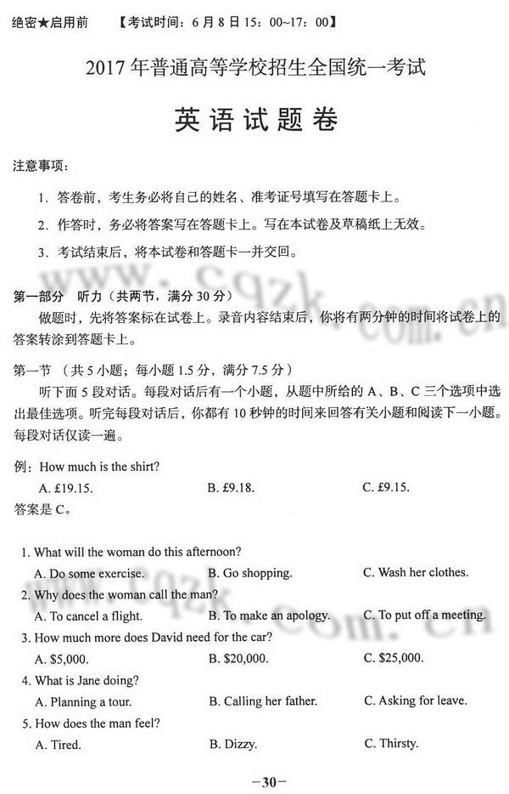
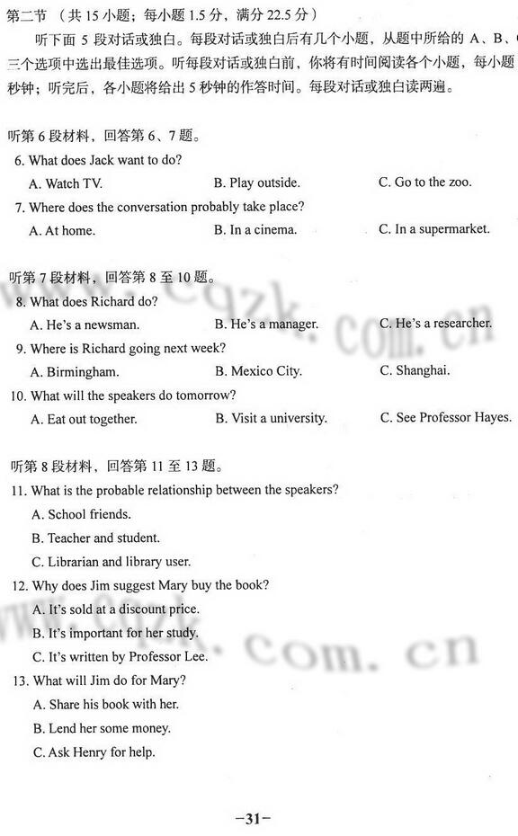
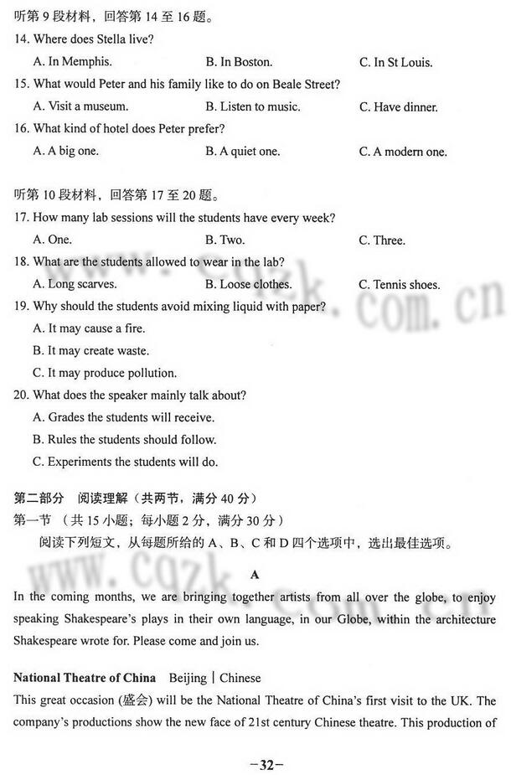
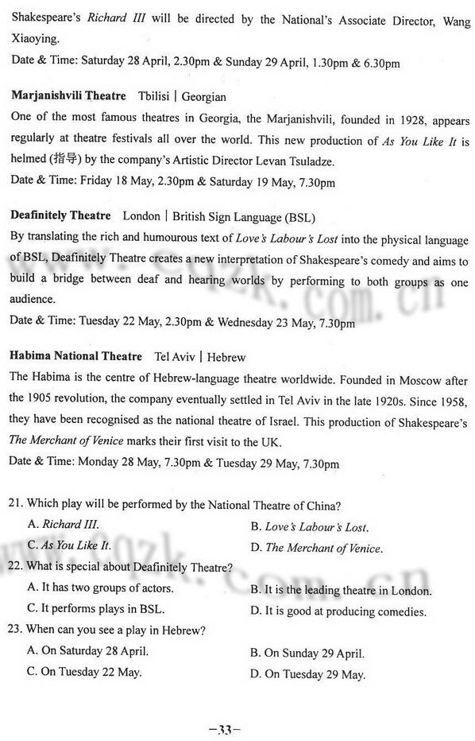
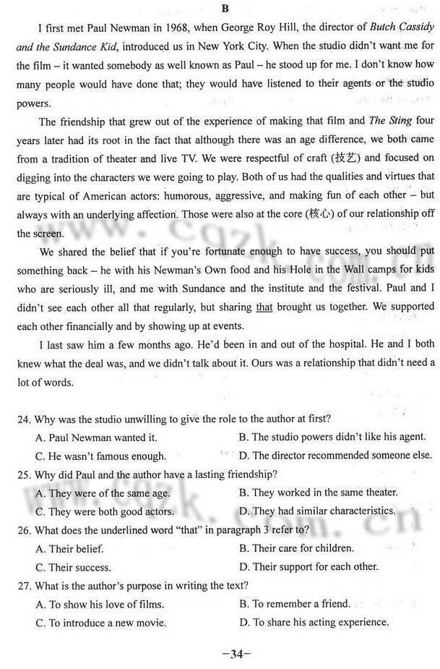
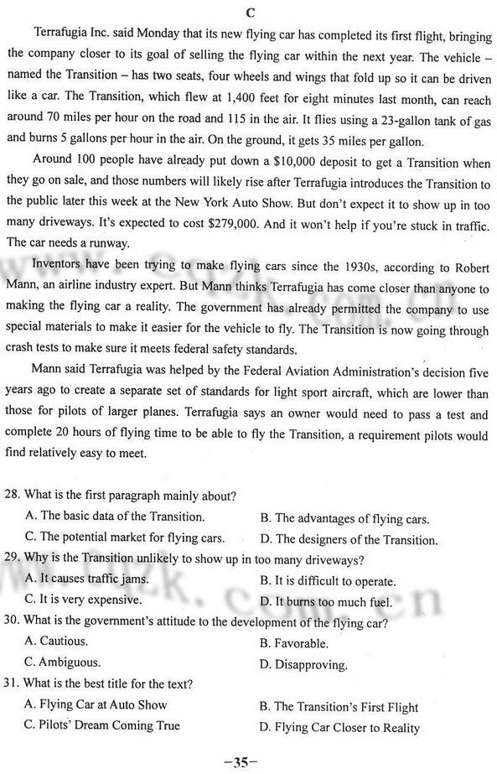
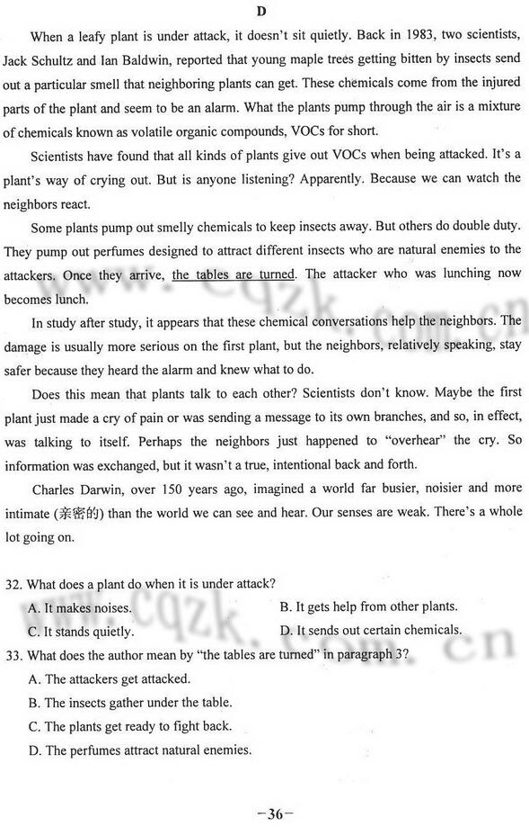
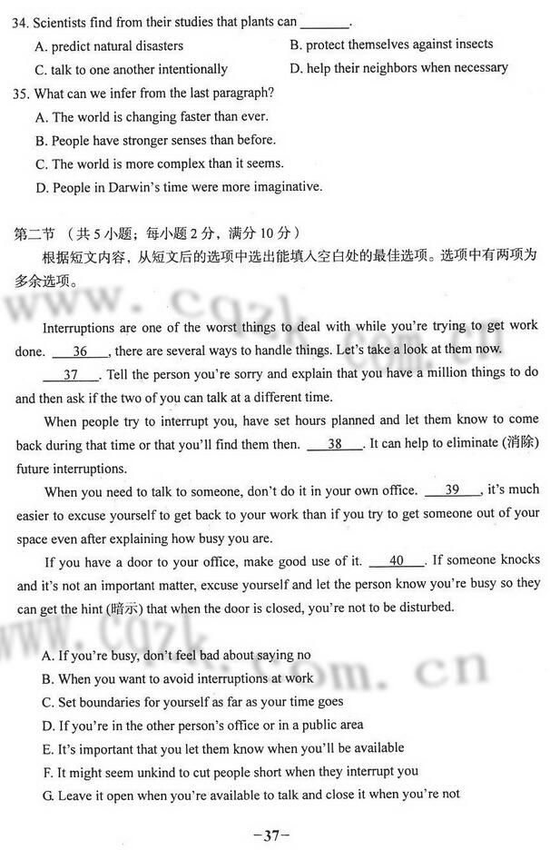
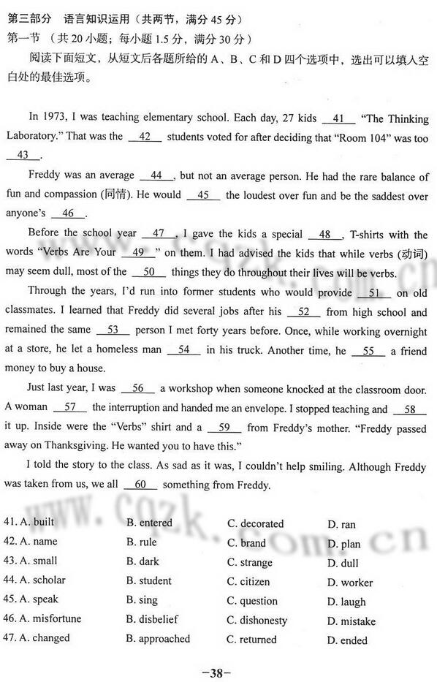
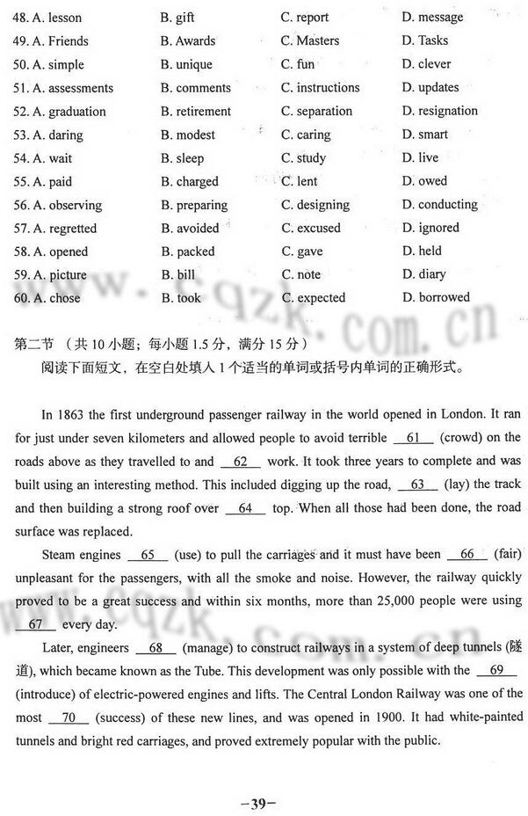
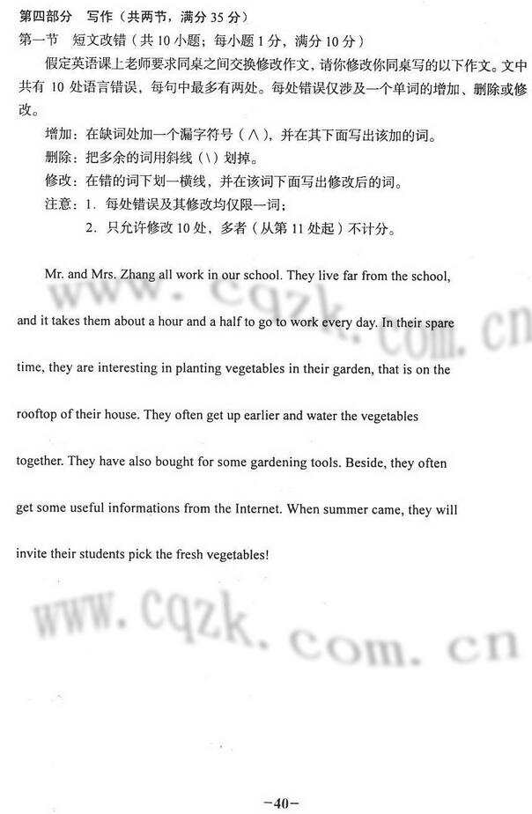
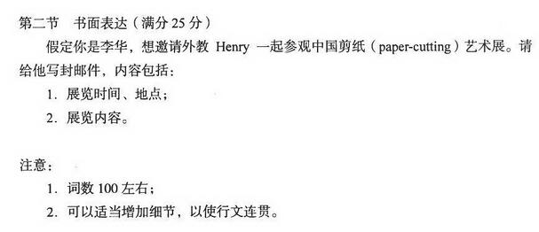
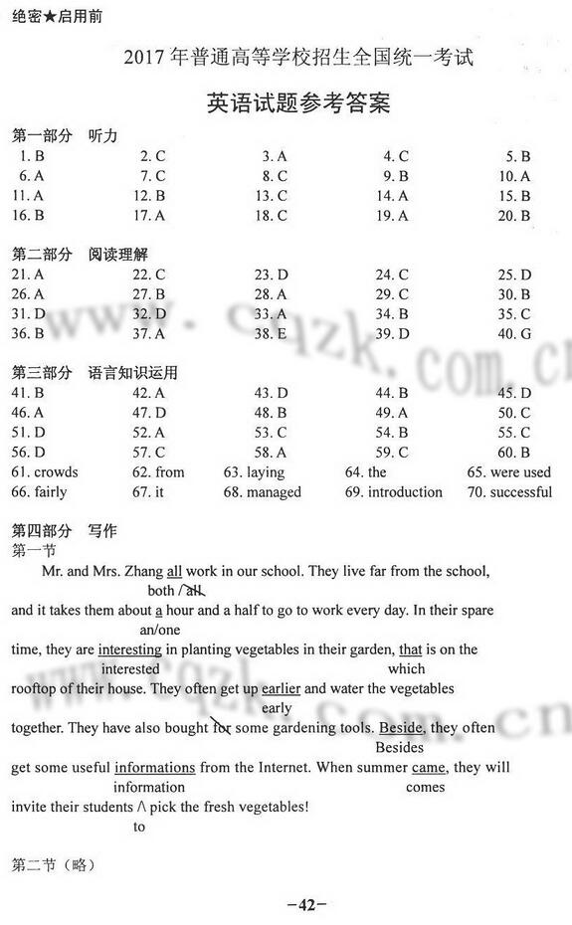
高清电子版试题请点击：https://app.gaokaozhitongche.com/news/14094 下载

绝密★启用前
2017年普通高等学校招生全国统一考试
英语试题参考答案

第一部分 听力
1. B 2. C 3. A 4. C 5. B 6. A 7. C 8. C 9. B 10. A 11. A 12. B
13. C 14. A 15. B 16. B 17. A 18. C 19. A 20. B
第二部分 阅读理解
21. A 22. C 23. D 24. C 25. D 26. A 27. B 28. A 29. C 30. B 31. D
32. D 33. A 34. B 35. C 36. B 37. A 38. E 39. D 40. G
第三部分 语言知识运用
41. B 42. A 43. D 44. B 45. D 46. A 47. D 48. B 49. A 50. C
51. D 52. A 53. C 54. B 55. C 56. D 57. C 58. A 59. C 60. B
61. crowds 62. from 63. z&xxk laying 64. the 65. were used
66. zxx.k fairly 67. it 68. managed 69. introduction 70. successful
第四部分 写作
第一节
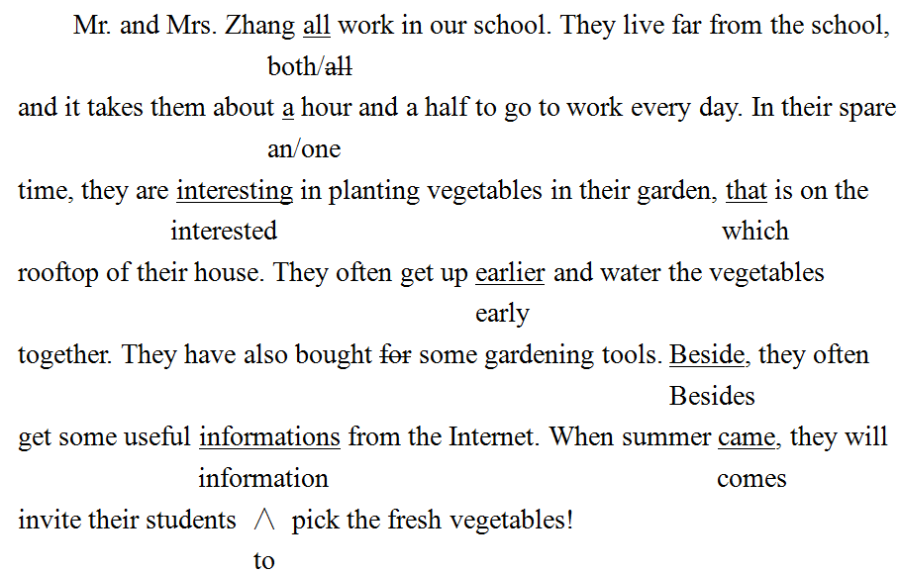
第二节（略）

